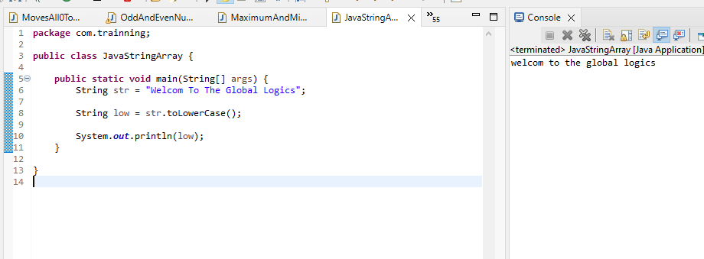1. Java program to convert all the characters in a string to lowercase

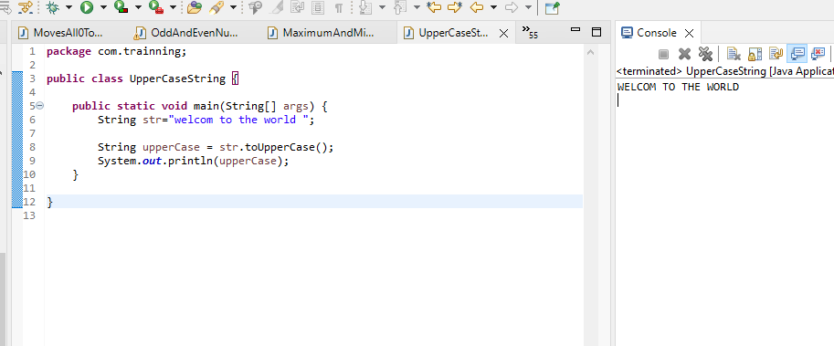2. Java program to convert all the characters in a string to uppercase

3. Write a Java program to create a character array containing the contents of a string

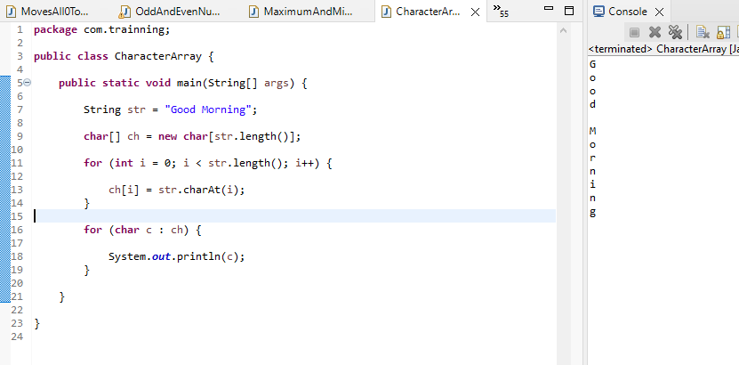

4. Java program to get a substring of a given string between two specified positions

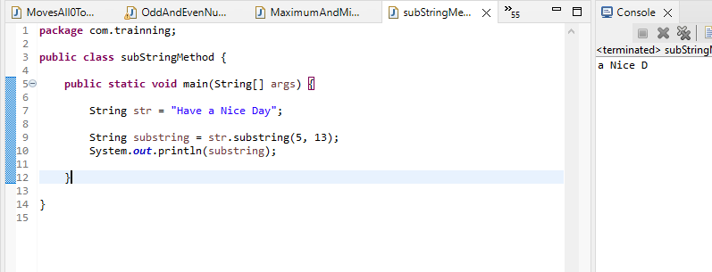

5.  Java program to check whether a given string starts with the contents of another string